### Trello + Github

Progress of the project was recorded through Trello; programmers could make tasks requesting art and assets from artists and designers, and then once complete, artists and designers could mark assets as complete after sending them to the correct person/putting them in the correct place.

Current builds of the project were kept on Github for easy access.

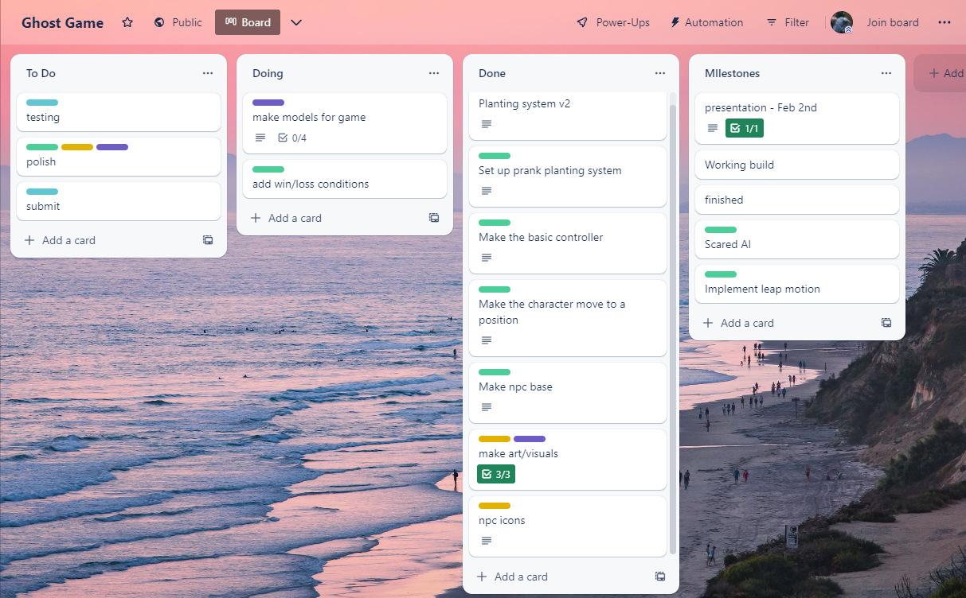

### UI concepts

General idea for the UI was to keep buttons and lettering large and bulky for easy of view, and to make interacting with the different items easier with less chance of accidentally selecting the wrong item.

### A drawing of a person Description automatically generated with medium confidenceObject concepts

Inspiration from paintings by Ayami Kojima, and various other gothic painters for paintings.

Various haunted items inspired by items in old hotels, simple designs but with an ‘old’ aesthetic.

### Floor tiles

Repeating pattern, inspiration from horror movies like ‘The Shining’; clashing + bright colours

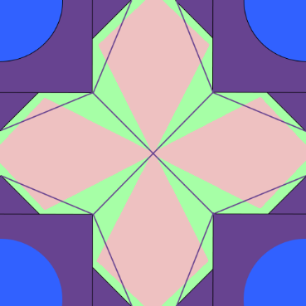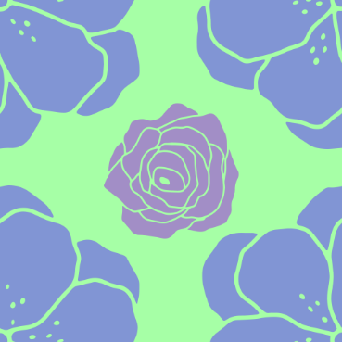

### Hotel guests

Used for a npc guest list; specifically to give the npcs more character without having to fully model hundreds of different variations in such a short amount of time

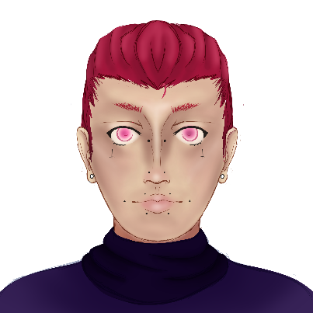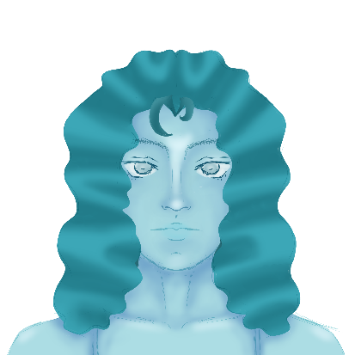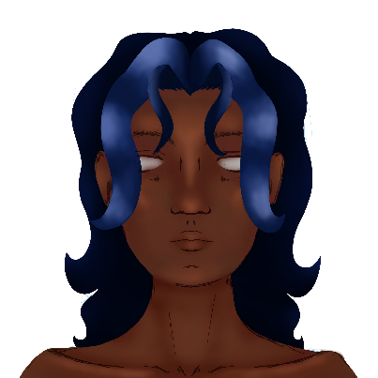

### Programming +

Some simple models made for decorations and traps. Far left is the AI guest that wanders around and gets scared by the traps. Behind that is a working door and left is the player character that runs around. The mirror spins around. The bookshelf flings two books out. The painting moves on its own and the draw opens and closes rapidly. The lamp swings around as if being pushed.

### 

Simple particle effects. The green one shows where the player character will move to and the brown one is a dust effect that plays when traps are made and destroyed.

This is the character. His arms and head are attached to body and they all wobble. He moves to where the player requests.

Below is the actual player controller. The grey cubes represent the boundaries of the camera (hidden in game). There are four orange buttons on the bottom which the player uses to navigate the world. They are operated using the leap motion controller which captures your hands in real time so you can virtually press the buttons. The black button on the side is for when the player chracter is in a trappable room. It will turn green showing the player they can trap the room.

This is the ai guest. It wanders to a random location and has a chance to question whether a ghost will do anything. When this happens, if the ai is in a room with a trap then said trap will activate scaring the guest and scoring the player some points.

### Models

Detailed picture frame with normal, ambient occlusion, roughness and metallic-ness. Trying to stick to the theme of a vintage hotel that has been around for some time.

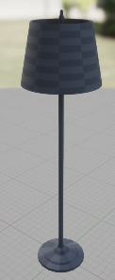

These are simple models for a lamp and a vase for use decorating the hotel. On the left is a retro crt screen which will be positioned in the reception of the hotel.

Classic wooden furniture to decorate the hotel with so its no longer empty. Most wood materials will have some weather on them to show age.

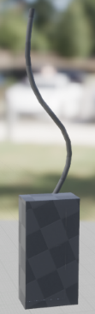

These are various other pieces of furniture and detailing for different parts of the hotel. The majority of these will be given a plain wood texture.

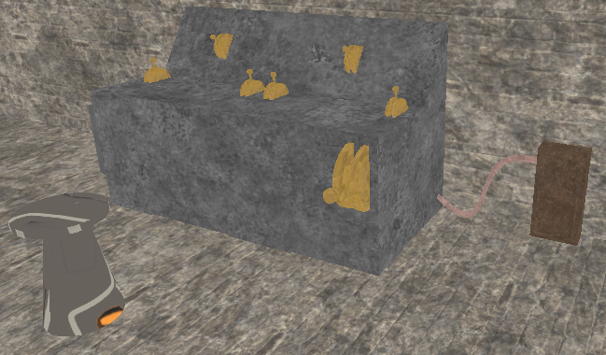This is the control board where, in the full game, the player will be able to manually trigger traps and remotely plant other tricks.